Performance Testing

Amount of Data Loaded

"Amount of Data Loaded" refers to the quantity or volume of data that has been imported, retrieved, or loaded into a system, software application, database, or any other data storage or processing environment. It's a measure of how much data has been successfully processed and made available for analysis, manipulation, or use within the system.

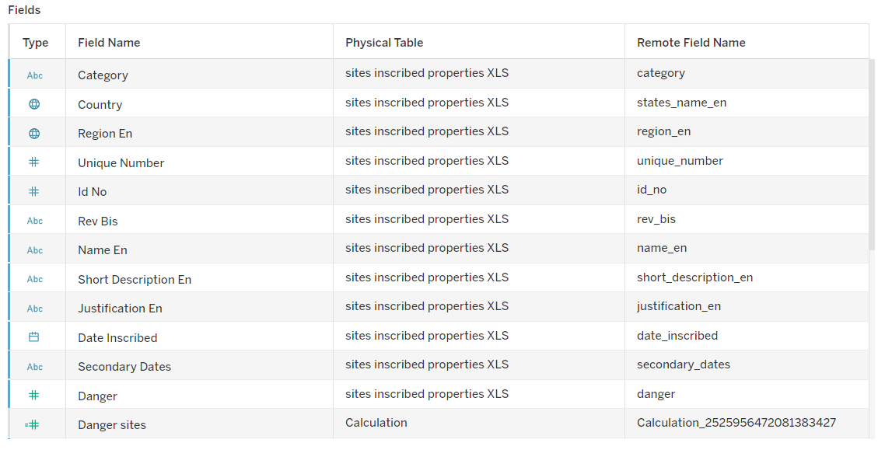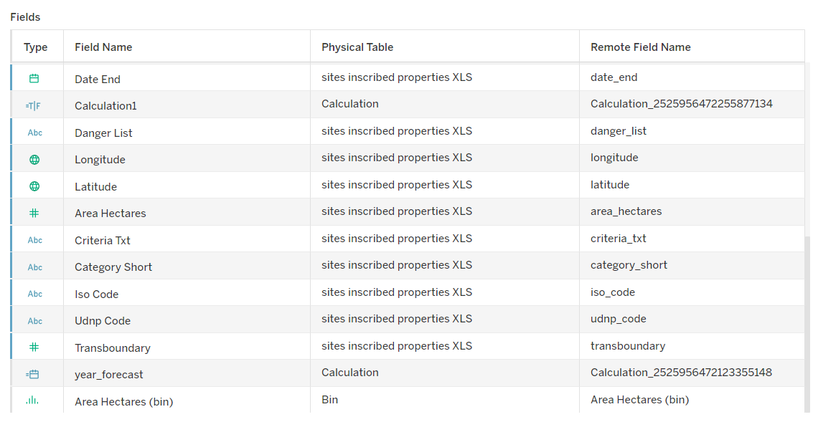

**Utilization of Data Filters**

Duration: 1 Hrs

Skill Tags:

"Utilization of Filters" refers to the application or use of filters within a system,software application, or data processing pipeline to selectively extract, manipulate, oranalyze data based on specified criteria or conditions

**Activity 2.1: Selected “Latin America” as a filter.**

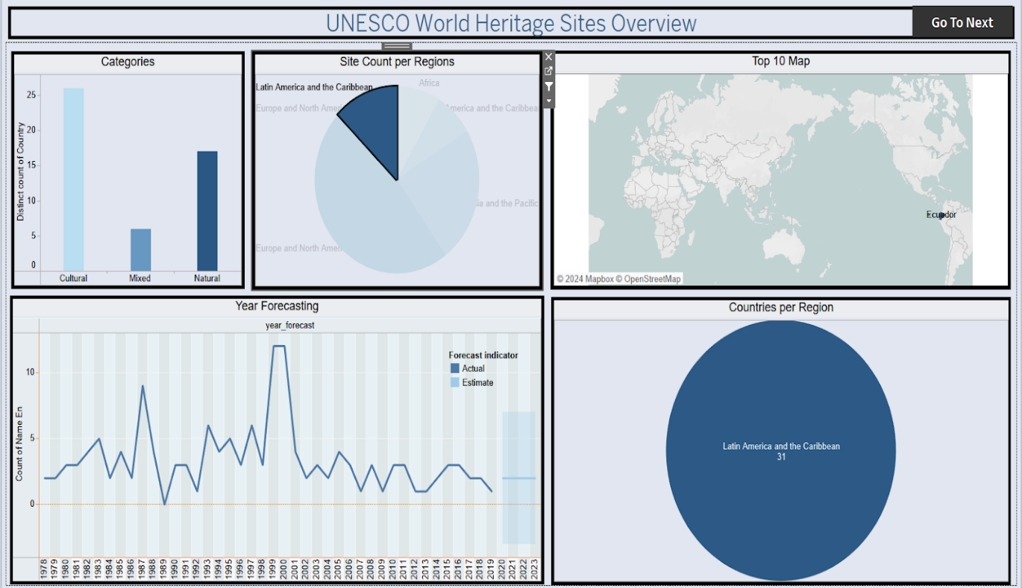

**Activity 2.2: Selected “Europe and North America” as a Filter**

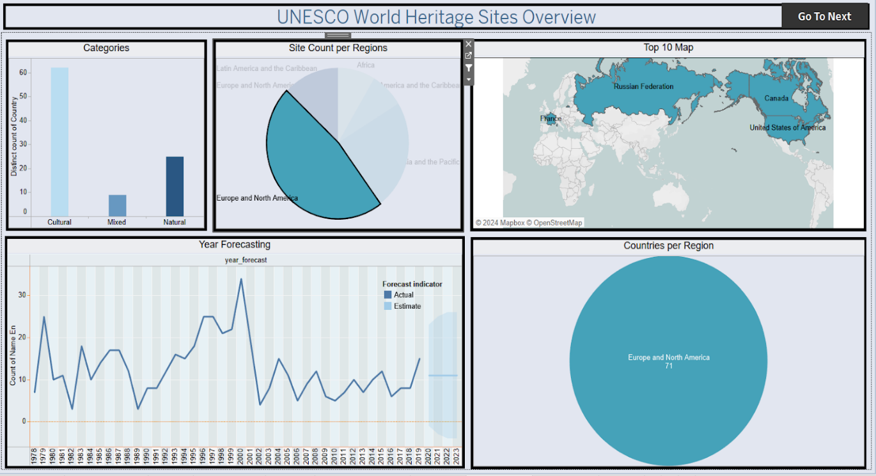

**📊 8. Number of Visualizations / Graphs**

**⏱️ Duration:**

**0.5 Hours**

**🧠 Skill Tags:**

* Data Visualization
* Graph Design in Tableau
* Comparative Analysis
* Forecasting
* Geographic Mapping
* Trend Analysis

**📘 Overview:**

A variety of **visualizations** were created using Tableau to extract deep insights from the UNESCO World Heritage Sites dataset. Each chart was selected to highlight specific aspects of the data, from geographical spread to endangered status and forecasting.

**📌 List of Key Visualizations / Graphs Created:**

1. **Top 10 Regions by Area**  
   → Bar chart showing the largest regions in terms of site area.
2. **Countries per Region**  
   → Stacked bar or map chart displaying how many countries fall under each region.
3. **Sites Count per Region**  
   → Horizontal bar chart to compare the number of heritage sites in each region.
4. **Analysis of Danger Sites and Areas**  
   → Pie chart and map showing distribution of endangered sites and affected regions.
5. **Heritage Ended Regions**  
   → Table or bar chart listing regions where sites have lost their World Heritage status.
6. **Year Forecasting**  
   → Line chart using trend forecasting to predict potential future inscriptions based on historical data.
7. **Categories by Site Count**  
   → Column chart dividing Cultural, Natural, and Mixed sites by count.
8. **Top 10 Danger Sites**  
   → Highlighted list or table of the most at-risk heritage sites globally.

**🎯 Outcome:**

These visualizations provide a **multi-dimensional analysis** of the heritage site data, offering insights into geography, conservation challenges, trends, and categorical breakdowns. They serve as the foundation for dashboards and story components used in the project.